# **Name: Abdurrahman Qureshi**

# **Roll No: 210451**

Practical No: 20

**1) Develop a program to update name of a student from Jack to John.**

import java.sql.*;  
public class exp18q2  
{  
 public static void main(String args[])  
 {  
 try  
 {  
 Class.*forName*("sun.jdbc.odbc.JdbcOdbcDriver");  
 Connection con=DriverManager.*getConnection*("jdbc:odbc:exp13");  
 Statement st=con.createStatement();  
  
 ResultSet rs=st.executeQuery("UPDATE student SET name='Jon' WHERE name='Jack'");  
  
 con.close();  
 }  
 catch(Exception e)  
 {  
 System.*out*.println(e.getMessage());  
 }  
 }  
}

**OUTPUT:**

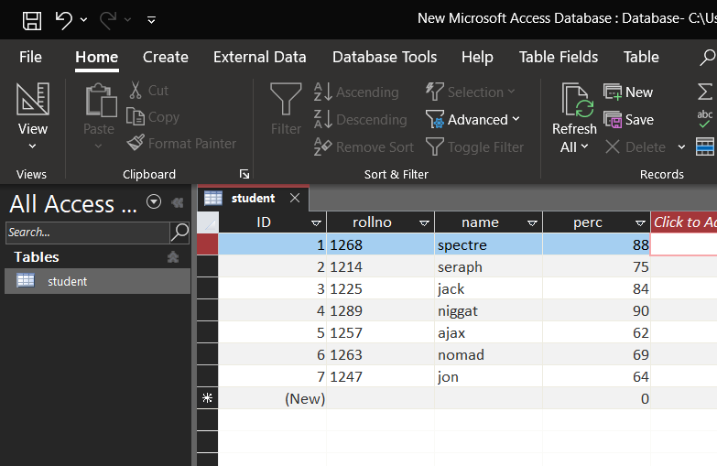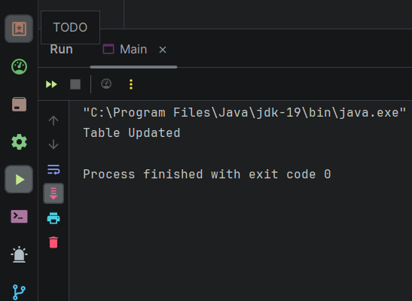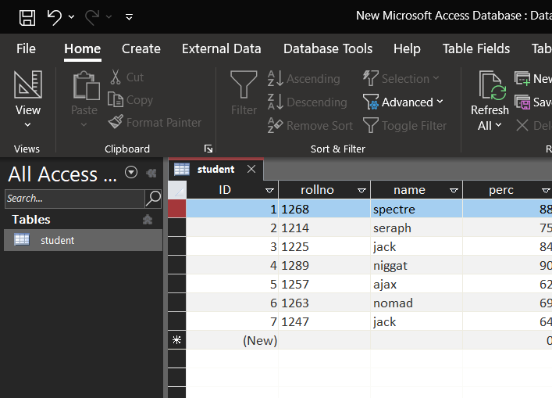

**2) Develop a program to delete all record for a product whose "price is greater than 500" and Id is "P1234".**

**CODE:**

import java.sql.*;  
public class exp18q2  
{  
 public static void main(String args[])  
 {  
 try  
 {  
 Class.*forName*("sun.jdbc.odbc.JdbcOdbcDriver");  
 Connection con=DriverManager.*getConnection*("jdbc:odbc:exp13");  
 Statement st=con.createStatement();  
  
 ResultSet rs=st.executeQuery("DELETE FROM product WHERE price>500 AND id='P1234'");  
  
 con.close();  
 }  
 catch(Exception e)  
 {  
 System.*out*.println(e.getMessage());  
 }  
 }  
}

**OUTPUT:**

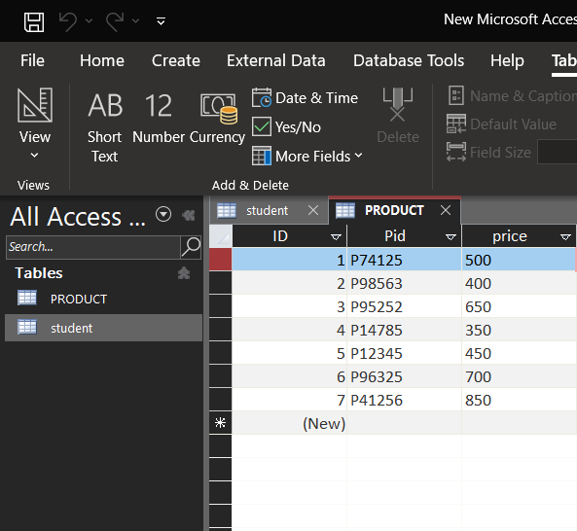

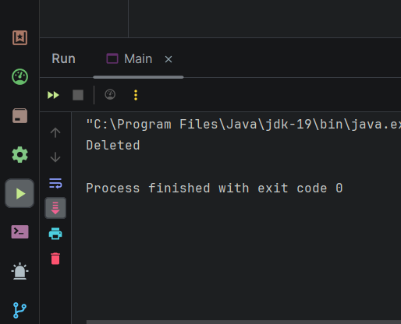

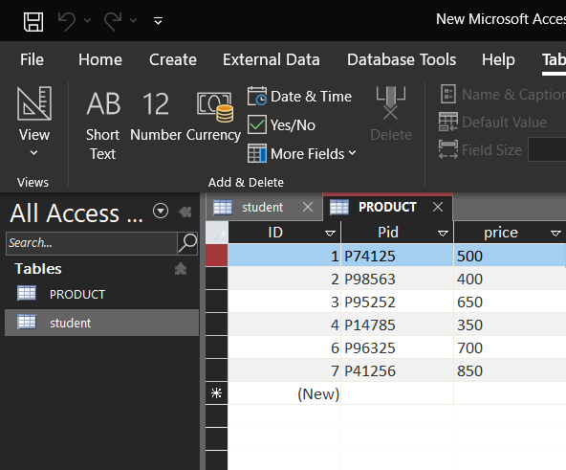

**3) Develop a program to a record from a table**

**CODE:**

import java.sql.*;  
public class exp18q2  
{  
 public static void main(String args[])  
 {  
 try  
 {  
 Class.*forName*("sun.jdbc.odbc.JdbcOdbcDriver");  
 Connection con=DriverManager.*getConnection*("jdbc:odbc:exp13");  
 Statement st=con.createStatement();  
  
 ResultSet rs=st.executeQuery("DELETE FROM product WHERE price>500 AND id='P1234'");  
  
 con.close();  
 }  
 catch(Exception e)  
 {  
 System.*out*.println(e.getMessage());  
 }  
 }  
}

**OUTPUT:**





